**INDRODUCTION**

**OVERVIEW:**

Develop an App for the management where buyers can order his requirements and get the appropriate details of the property. According to his interest just provide him with some discounts upto what extent he can get the discount .Also Tract Whether he is interested in taking the loan available for so just calculate how much loan amount user can get it .Provide the security for two different profiles like for marketing and sales team. Then finally create the reports and dashboards so there will be clear view just get to reports on the count of loan passed getting the property purchased close the deal.

A property management application built on Salesforce can be a powerful tool for managing properties, tenants, leases, and finances. The application can be customized to meet the specific needs of a property management company, allowing for efficient and streamlined management of properties.

PURPOSE:

The purpose of a property management application built on Salesforce is to provide property management companies with a centralized and efficient way to manage their properties, tenants, leases, and finances. The application can help property managers to streamline their workflows, automate manual tasks, and make informed decisions based on accurate and up-to-date data.

Some specific purposes of a property management application using Salesforce include:

1. Property and Tenant Management: The application can provide a single source of truth for property and tenant information, including leases, payments, work orders, and maintenance requests. This can help property managers to quickly access the information they need to manage their properties and tenants effectively.
2. Marketing and Sales Management: The application can help property managers to track and manage marketing and sales activities, including lead tracking, marketing campaigns, and sales forecasting. This can help property managers to identify new opportunities and optimize their marketing efforts to attract new tenants.
3. Financial Management: The application can provide a complete view of financial data, including rent collection, expenses, and financial statements. This can help property managers to track revenue and expenses, monitor cash flow, and make informed financial decisions.
4. Customization and Integration: The application can be customized to meet the specific needs of a property management company, and integrated with other tools and systems, such as accounting software, payment processors, and property management software. This can help property managers to optimize their workflows and improve productivity.

Overall, the purpose of a property management application using Salesforce is to provide property managers with a comprehensive and efficient solution for managing their properties, tenants, and finances, helping them to make informed decisions and achieve their business.

**Problem definition and design thinking**

**Empathy map:**

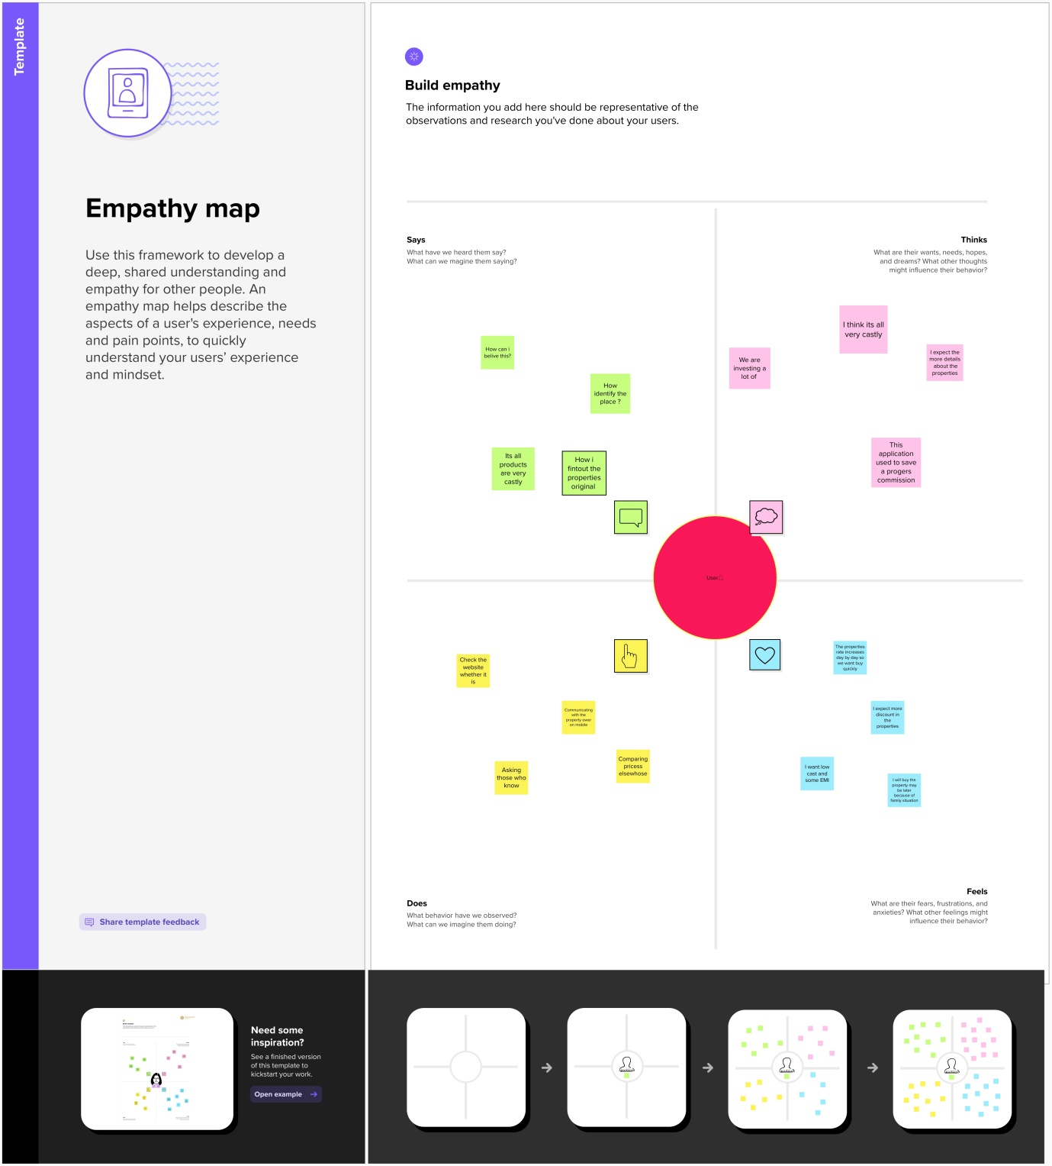

**IDEATION AND BRAINSTOMING MAP**

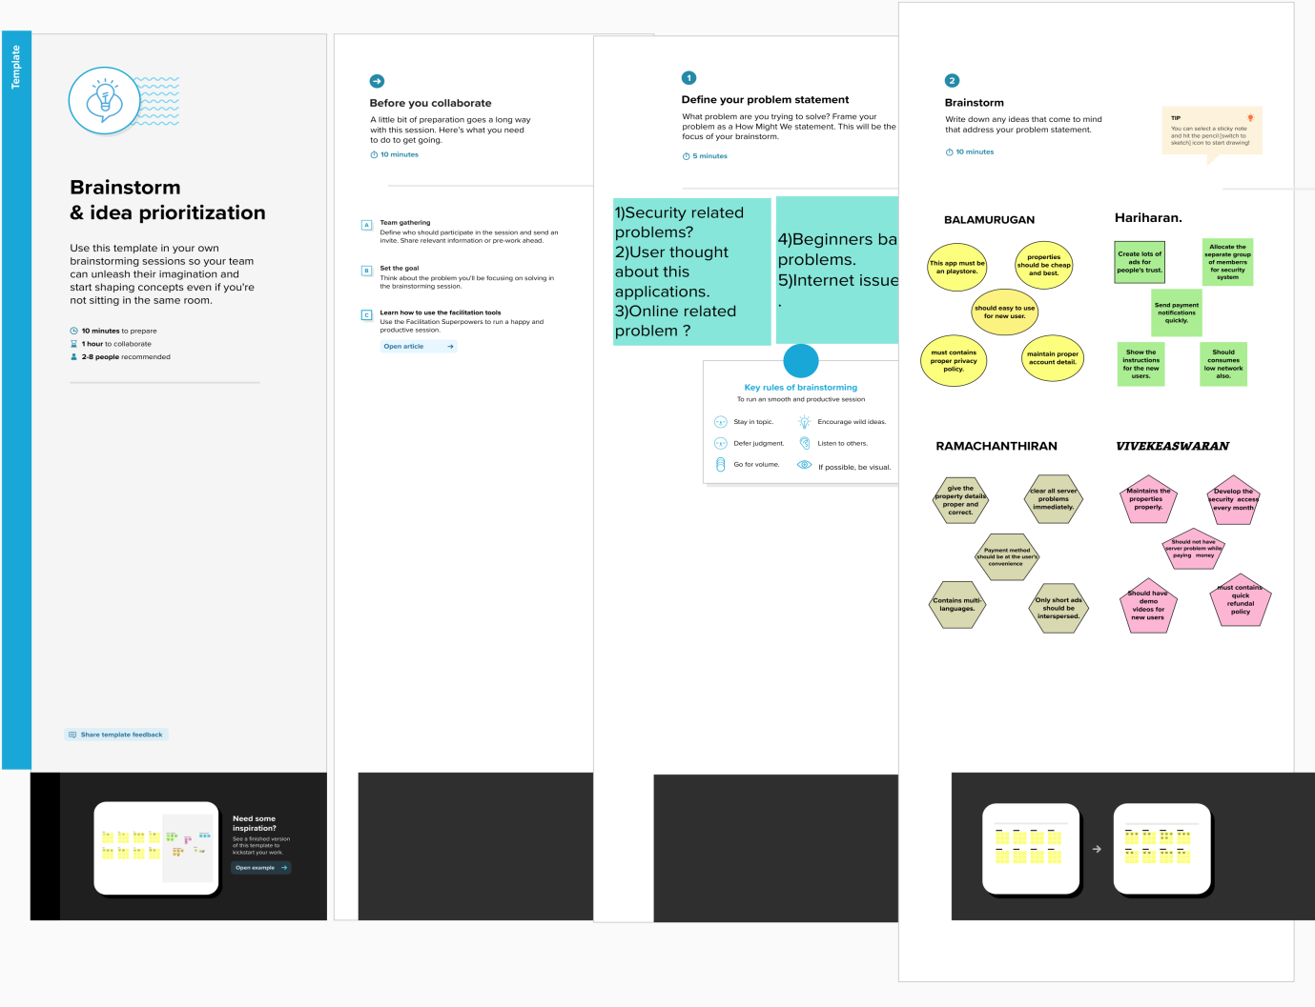

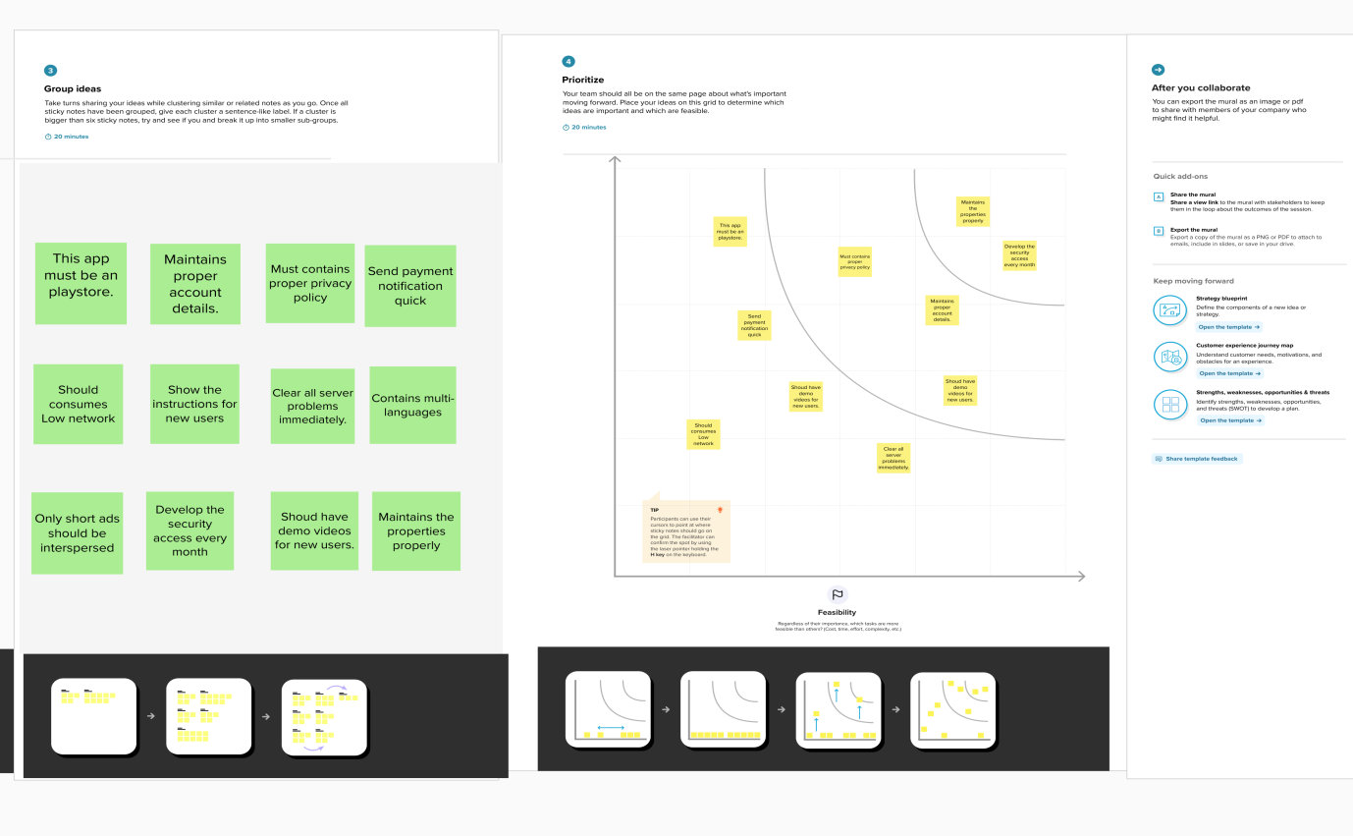

**RESULT**

**Data Model:**

|  |  |  |
| --- | --- | --- |
| Object name | Fields in the object |  |
|  | Field lable | Data type |
| Lead | Lead  ----------------------------------------------  State  ----------------------------------------------  City  ----------------------------------------------  Email  phone | Autonumber  --------------------------------------------  Picklist  ----------------------------------------------  Picklist  ---------------------------------------------  Email  Phone |
| Buy | Property type  Discount  State  City  Annual amount  buy | Picklist  Percentage  Picklist  Picklist  Currency  Text area |
| Rent | Rent  ----------------------------------------------  Rental city  ----------------------------------------------  BHK type  ----------------------------------------------  Rent | Autonumber  -----------------------------------------------  Text  -----------------------------------------------  Picklist  -----------------------------------------------  Text area |
| Loan | Loan id  ----------------------------------------------  Interest rate  ---------------------------------------------  Term  --------------------------------------------  Annual loam  ---------------------------------------------  Total loan instalment  --------------------------------------------  Loan repayment  ----------------------------------------------  Loan amonut | Autonumber  -----------------------------------------------  Currency  -----------------------------------------------  Number  -----------------------------------------------  Number  ----------------------------------------------  Number  -----------------------------------------------  Number  ----------------------------------------------  Formula |

**Activity & Screenshot**

Milestone 1:login sales force

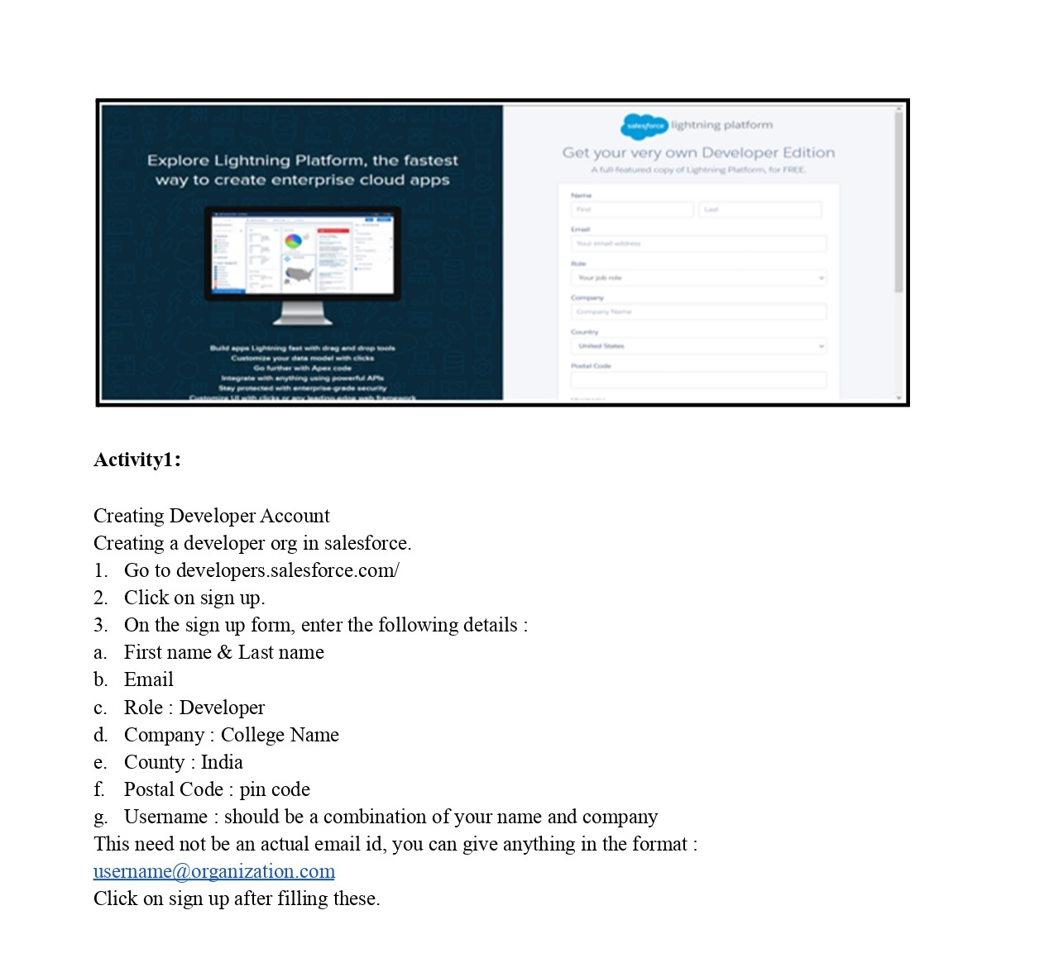

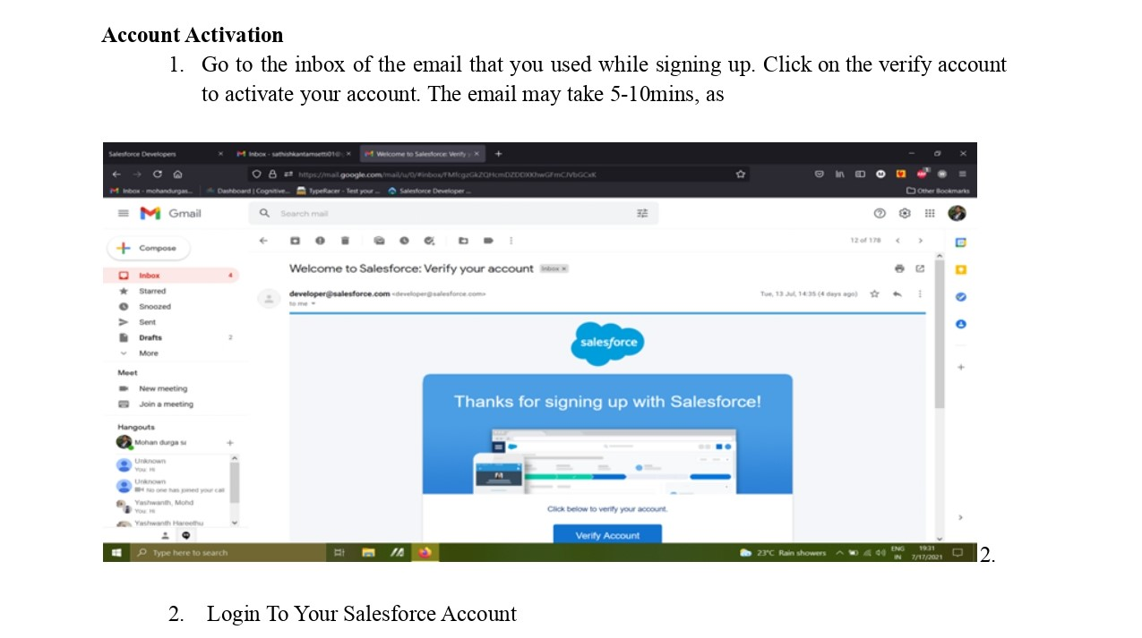

Mailstone 2:object

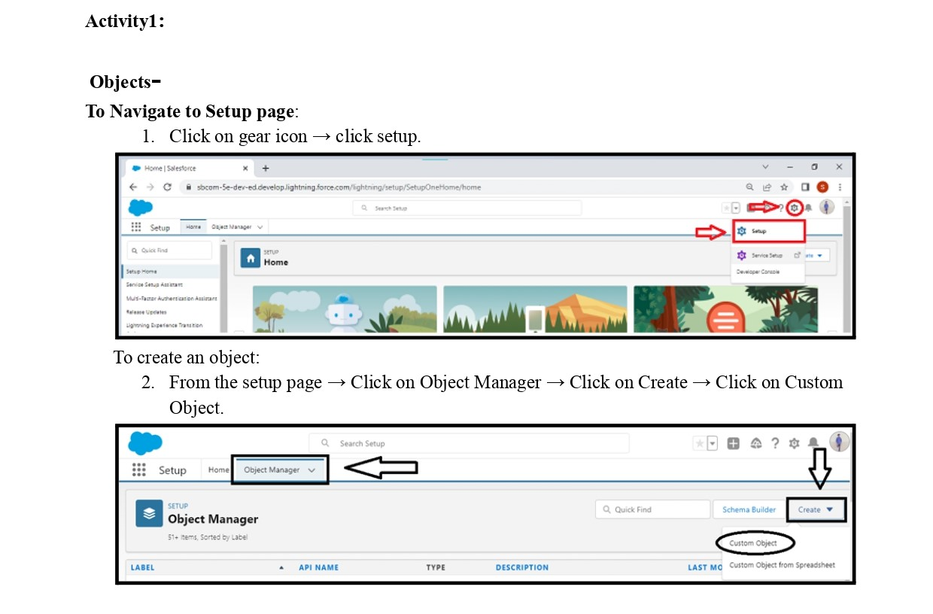

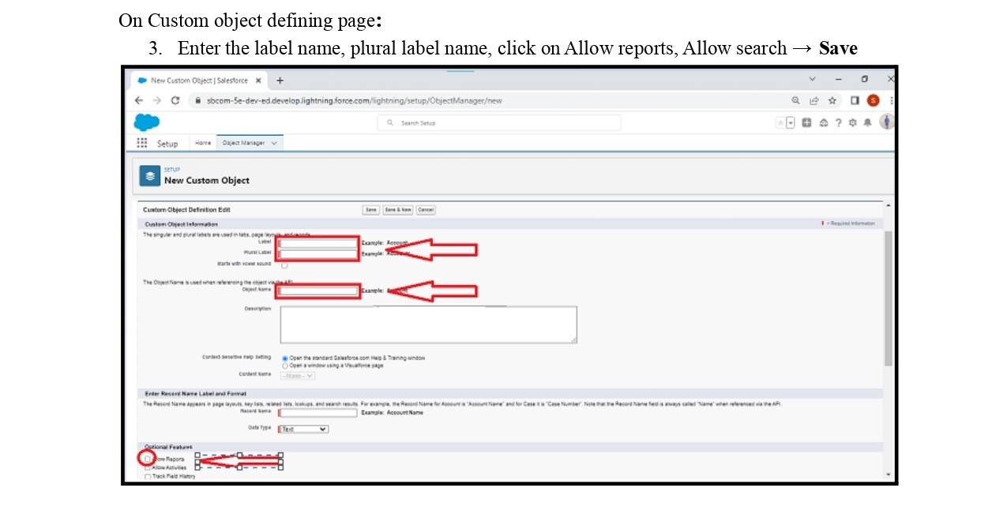

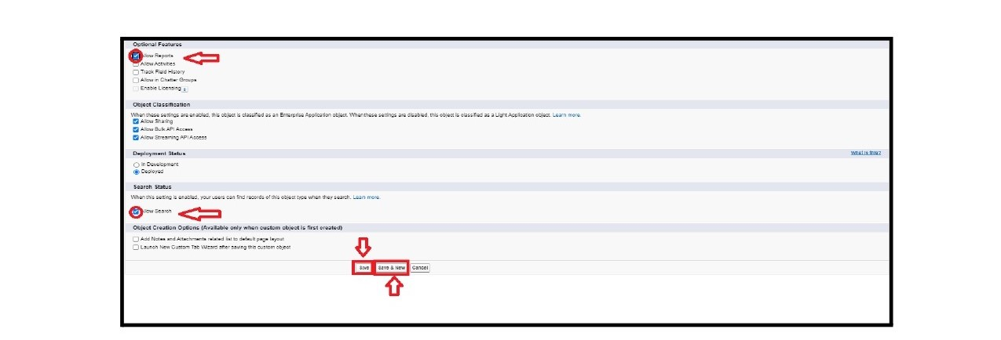

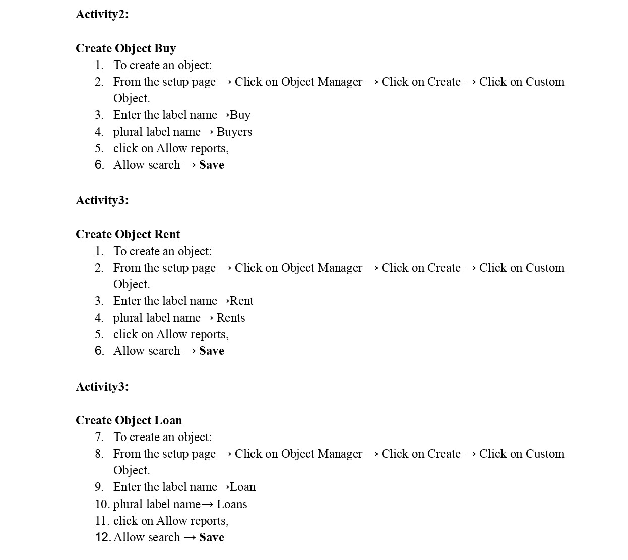

Mailstone 3:tab

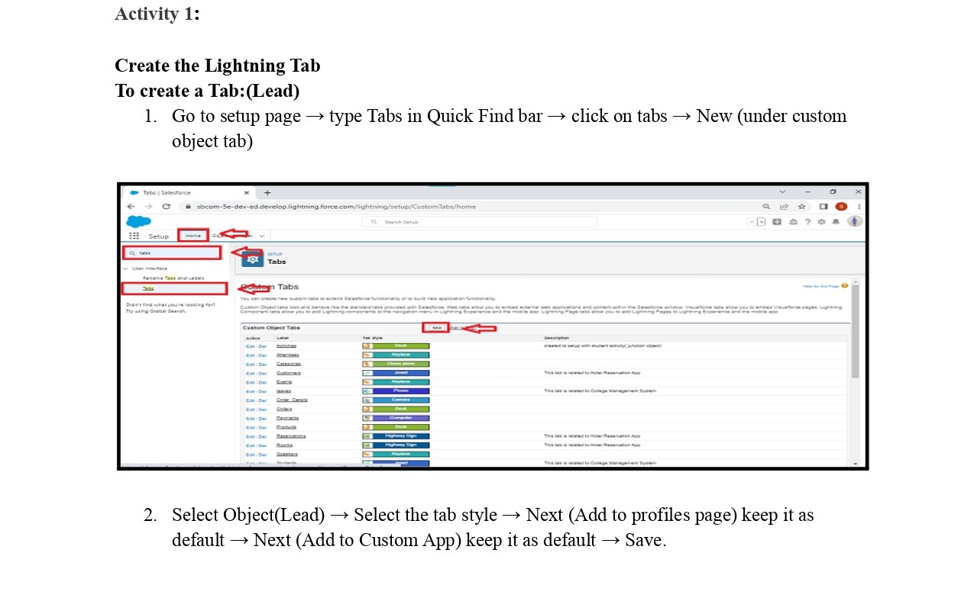

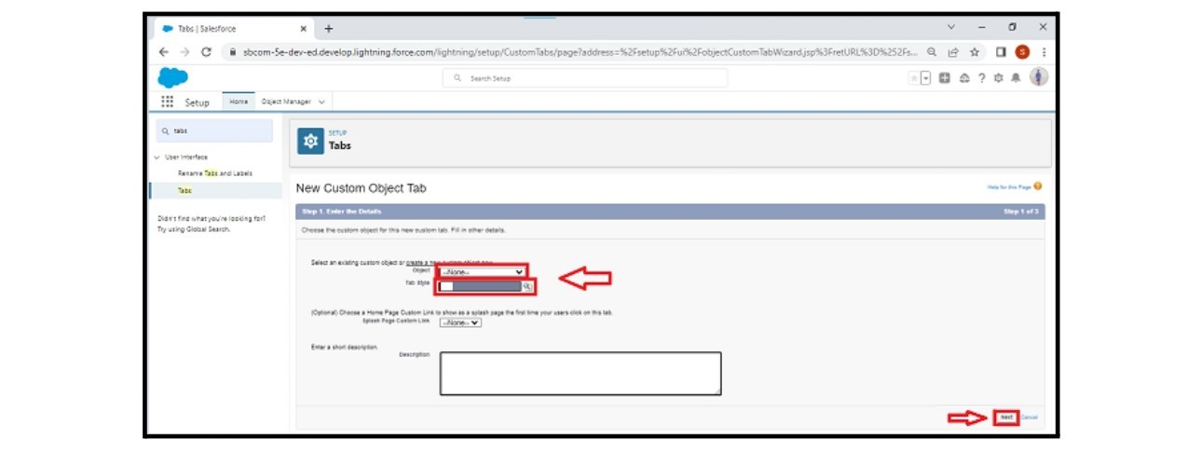

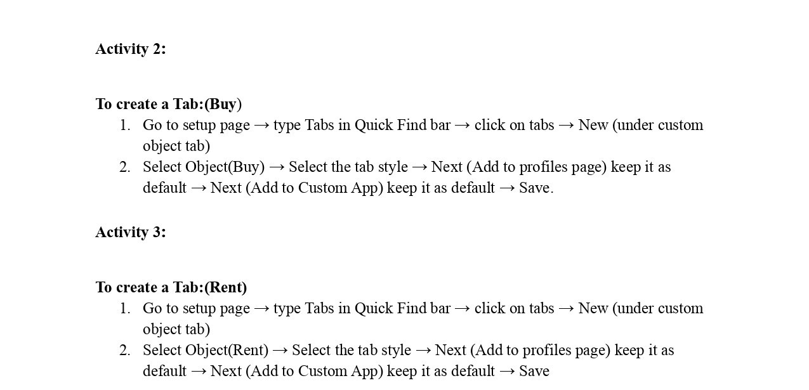

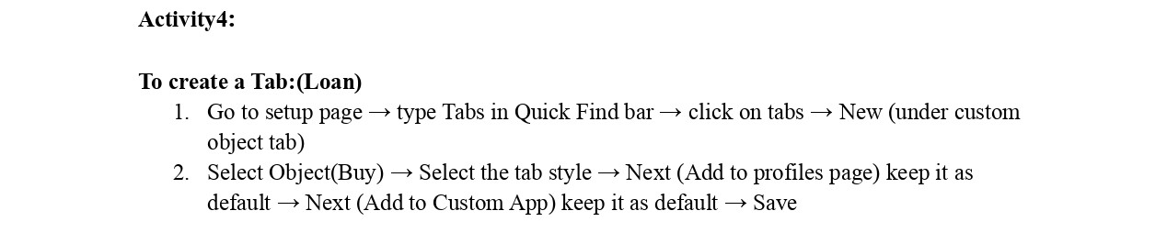

Mailstone 4:The lighting app

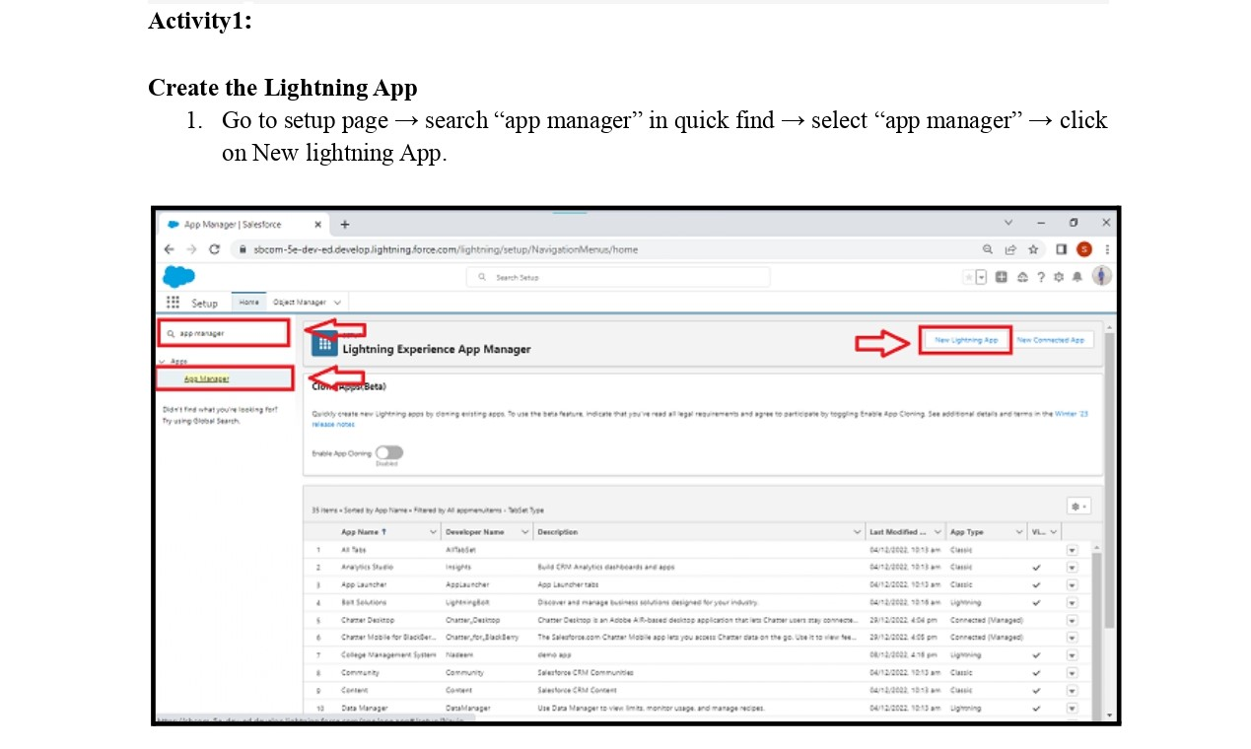

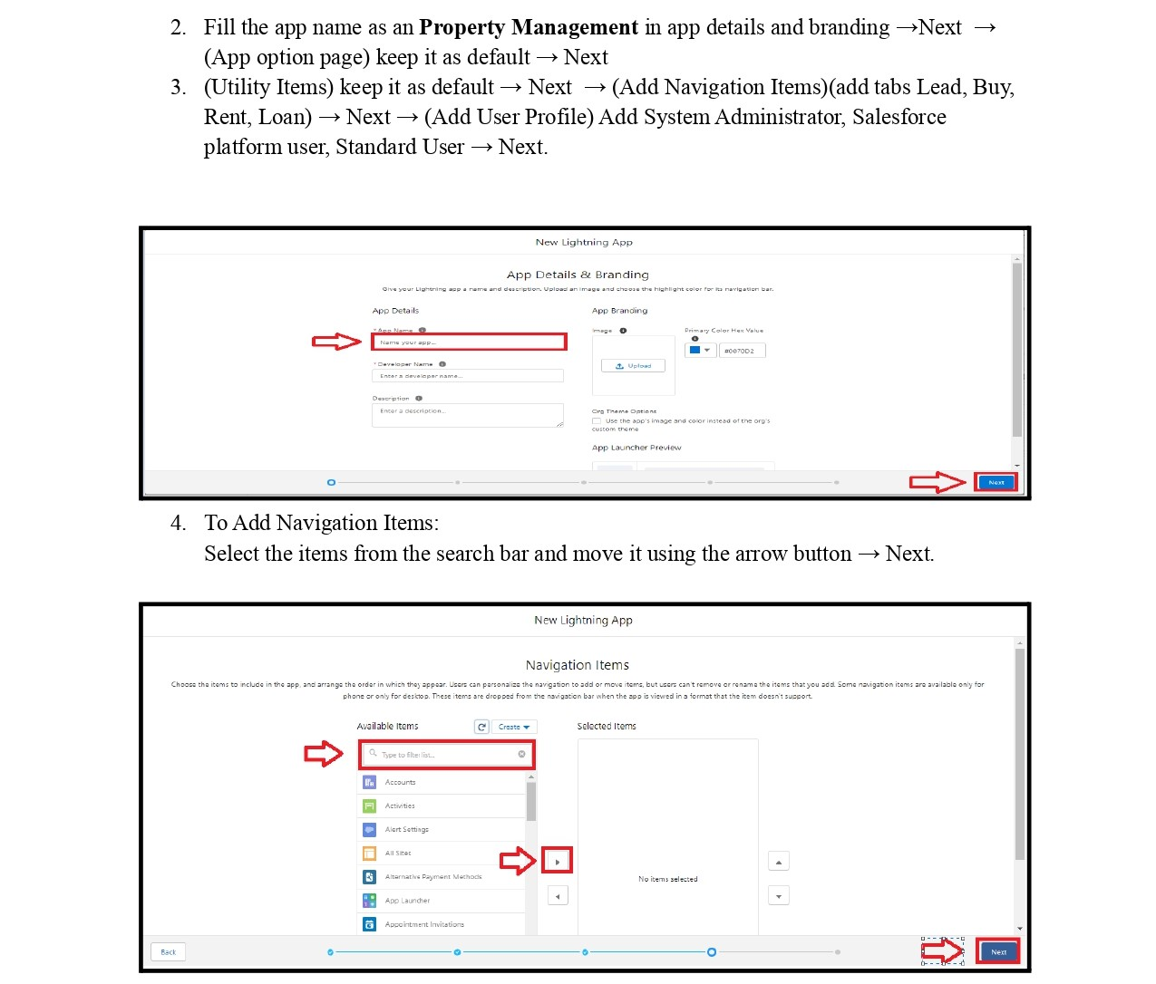

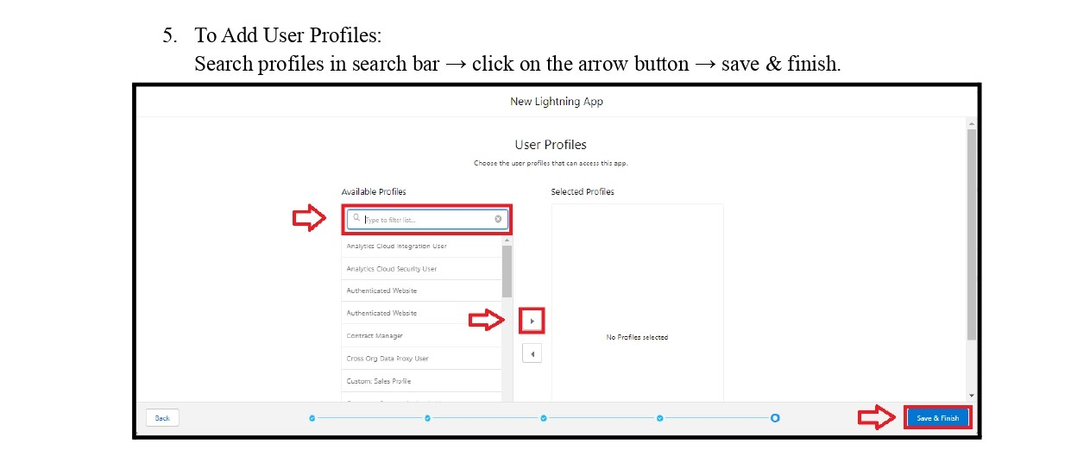

Mailstone 5:fields

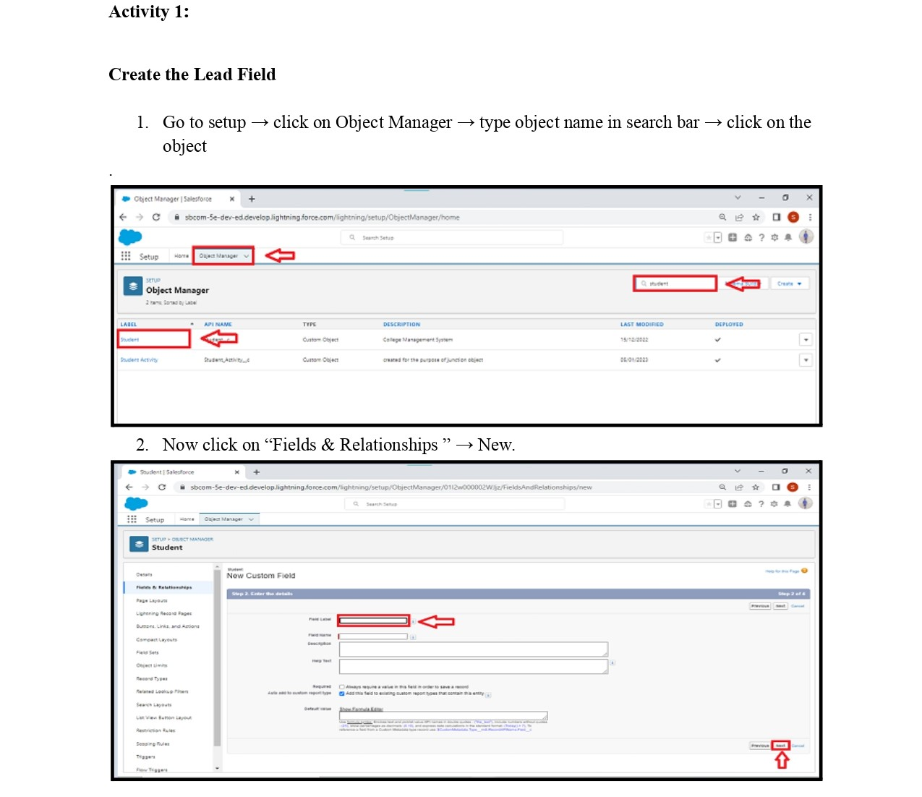

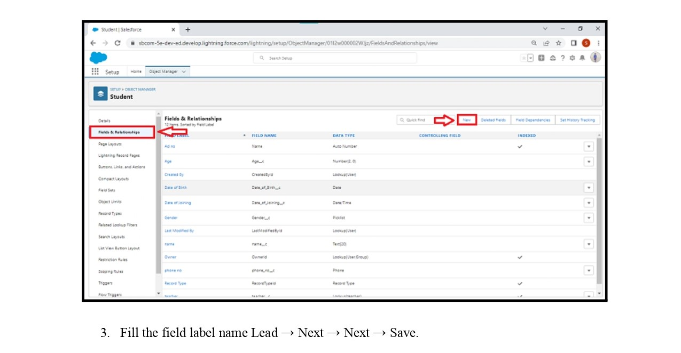

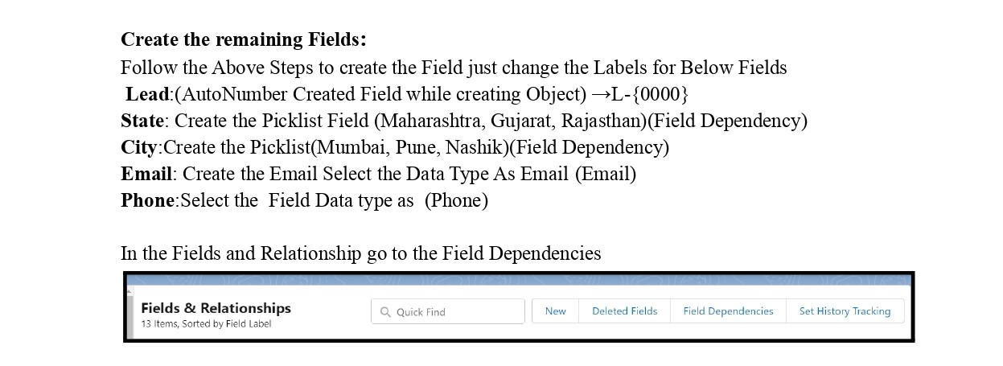

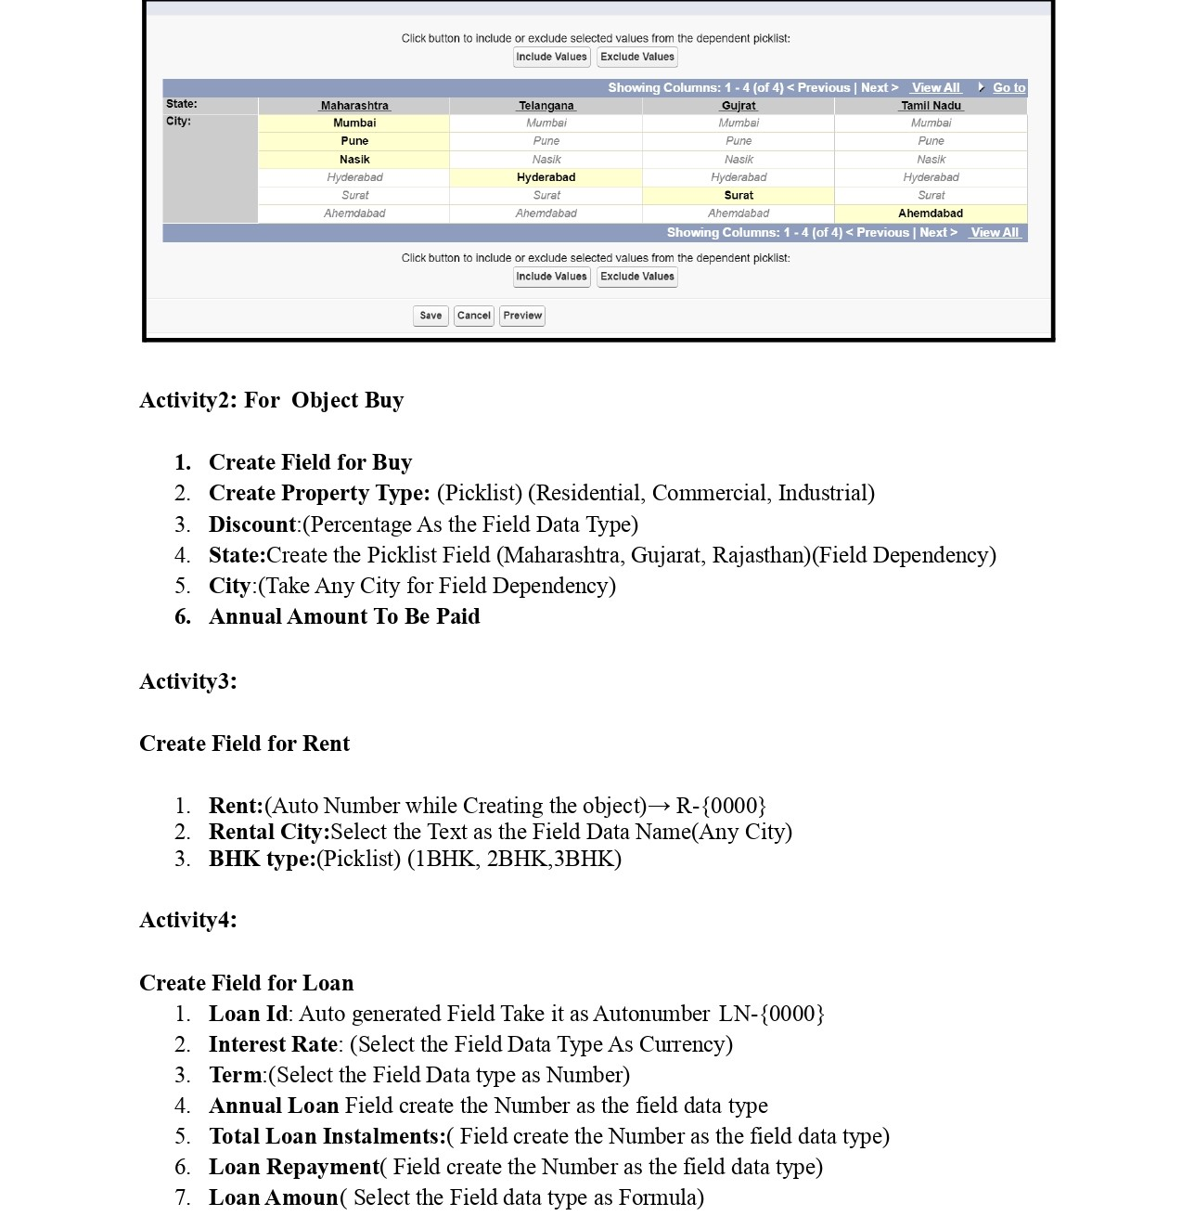

Brainstome 6:profiles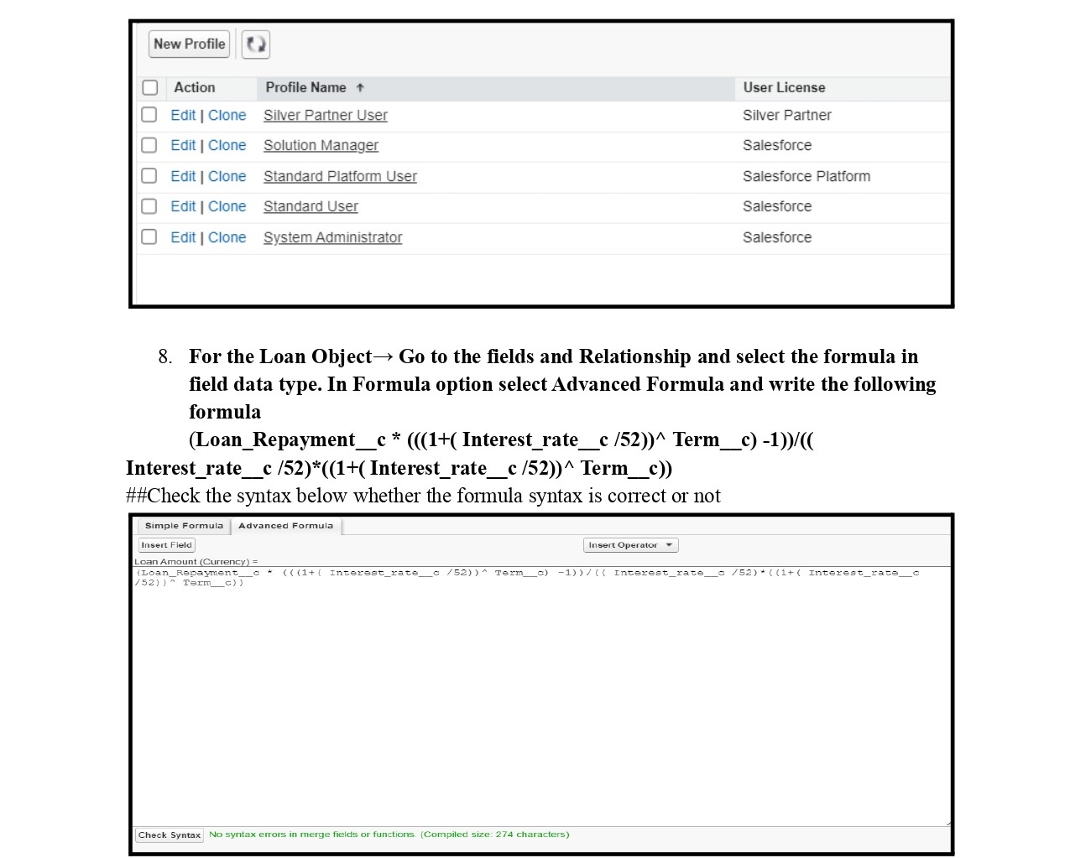

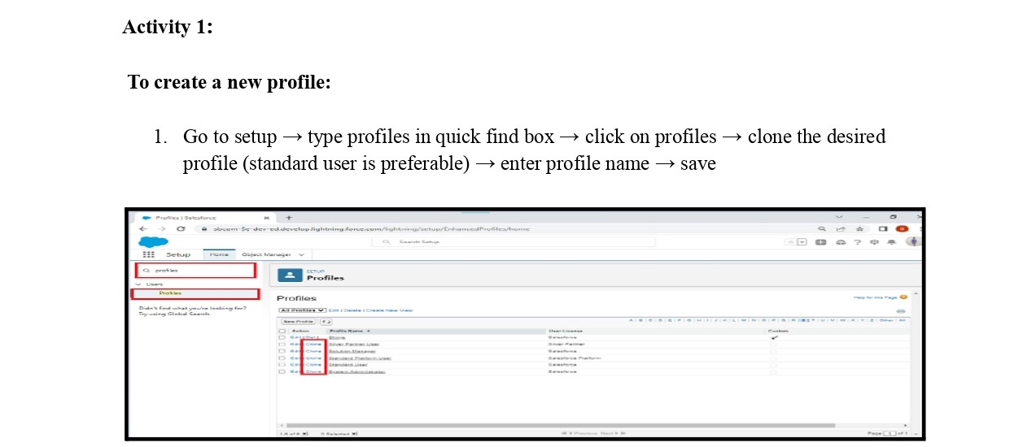

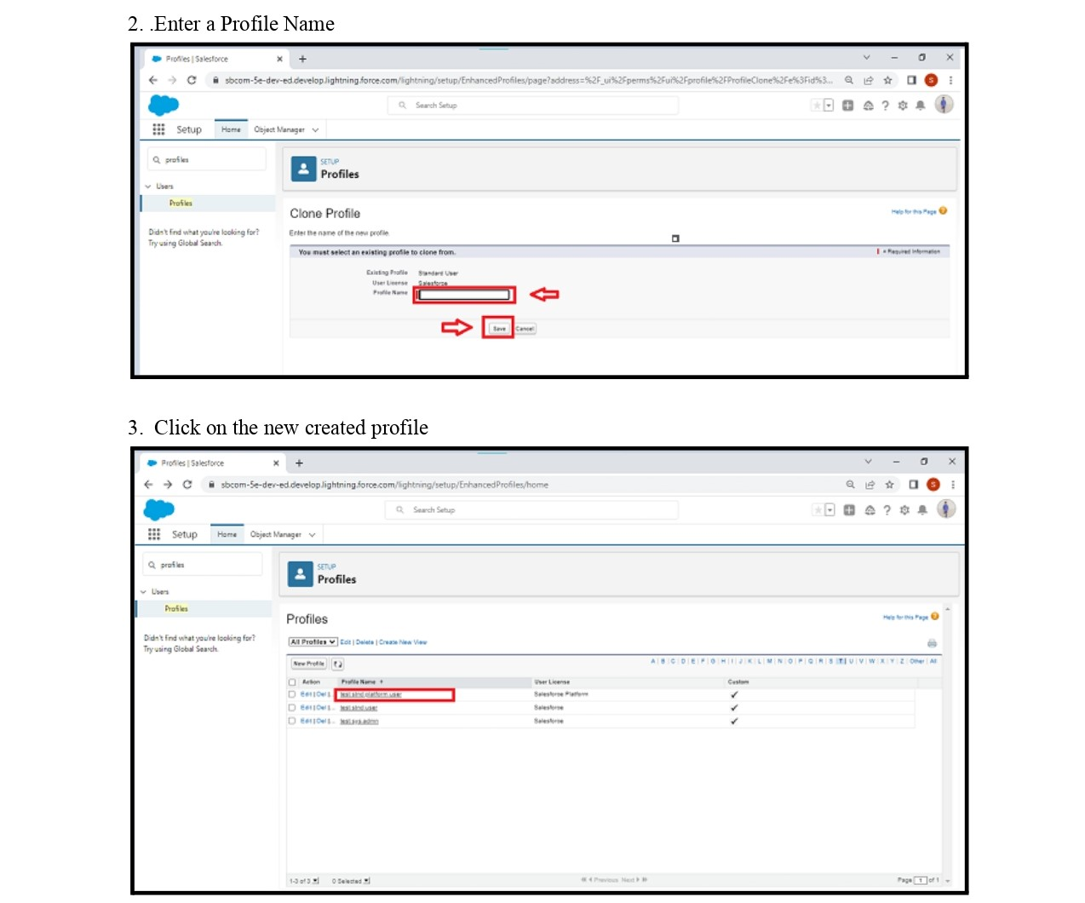

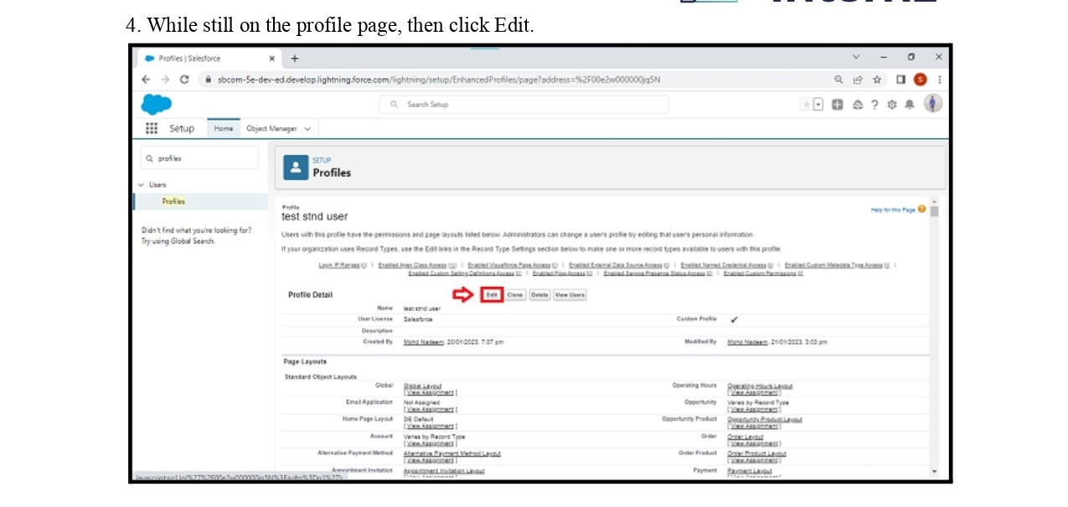

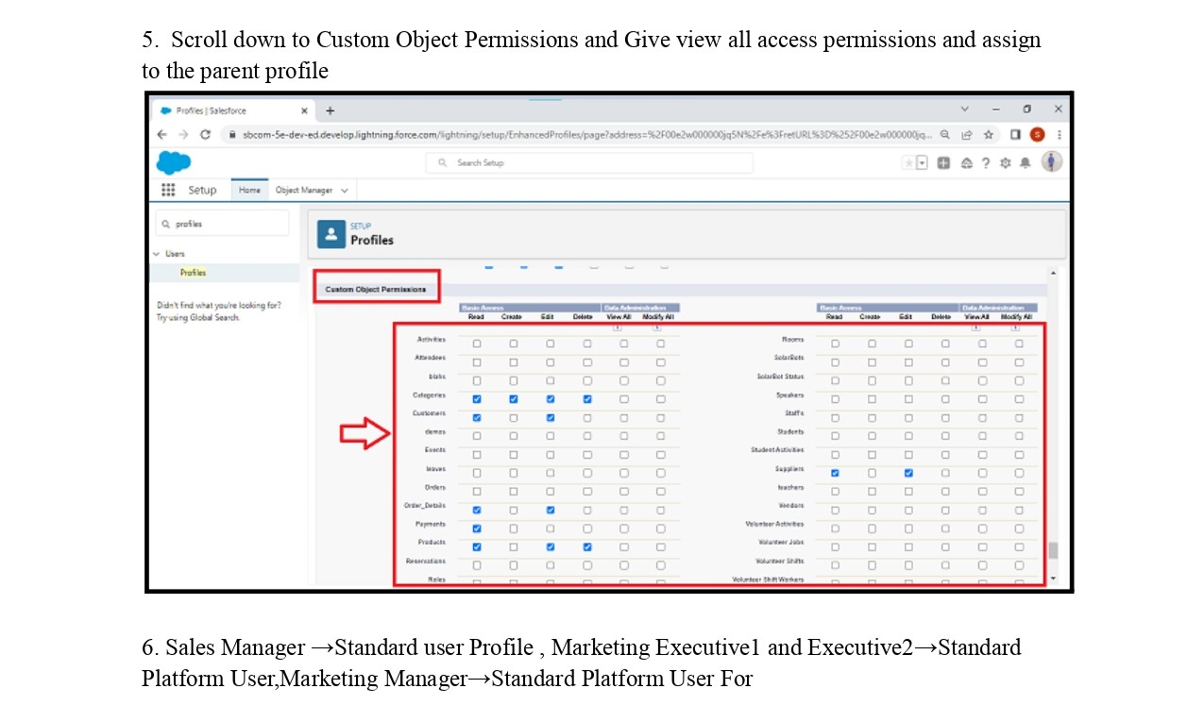

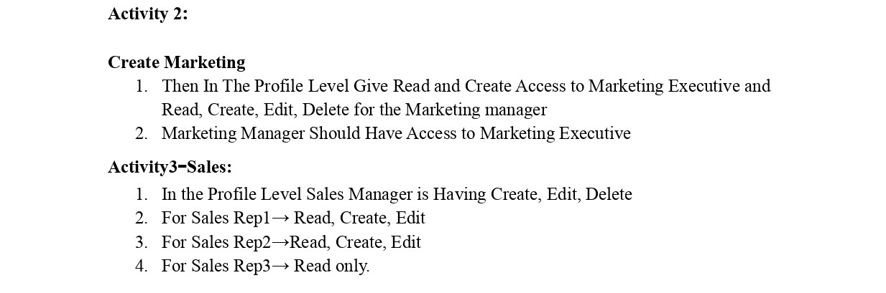

Mailstone 7:new user

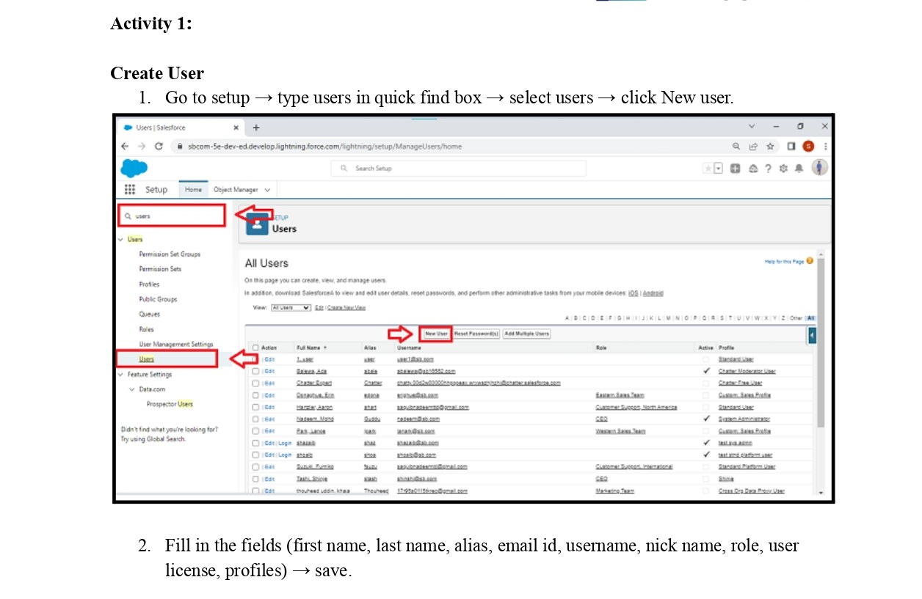

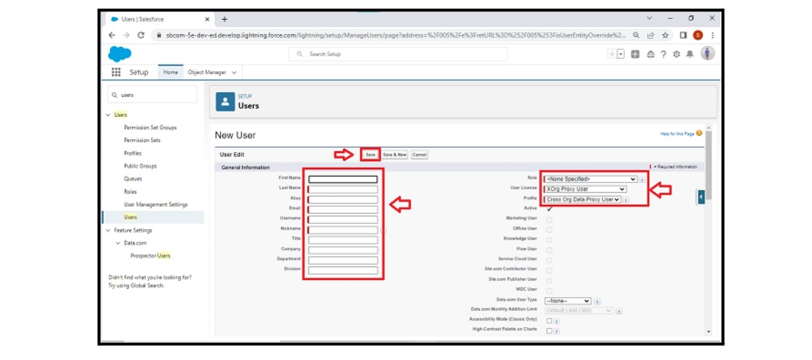

Mailstone 8:permission sets

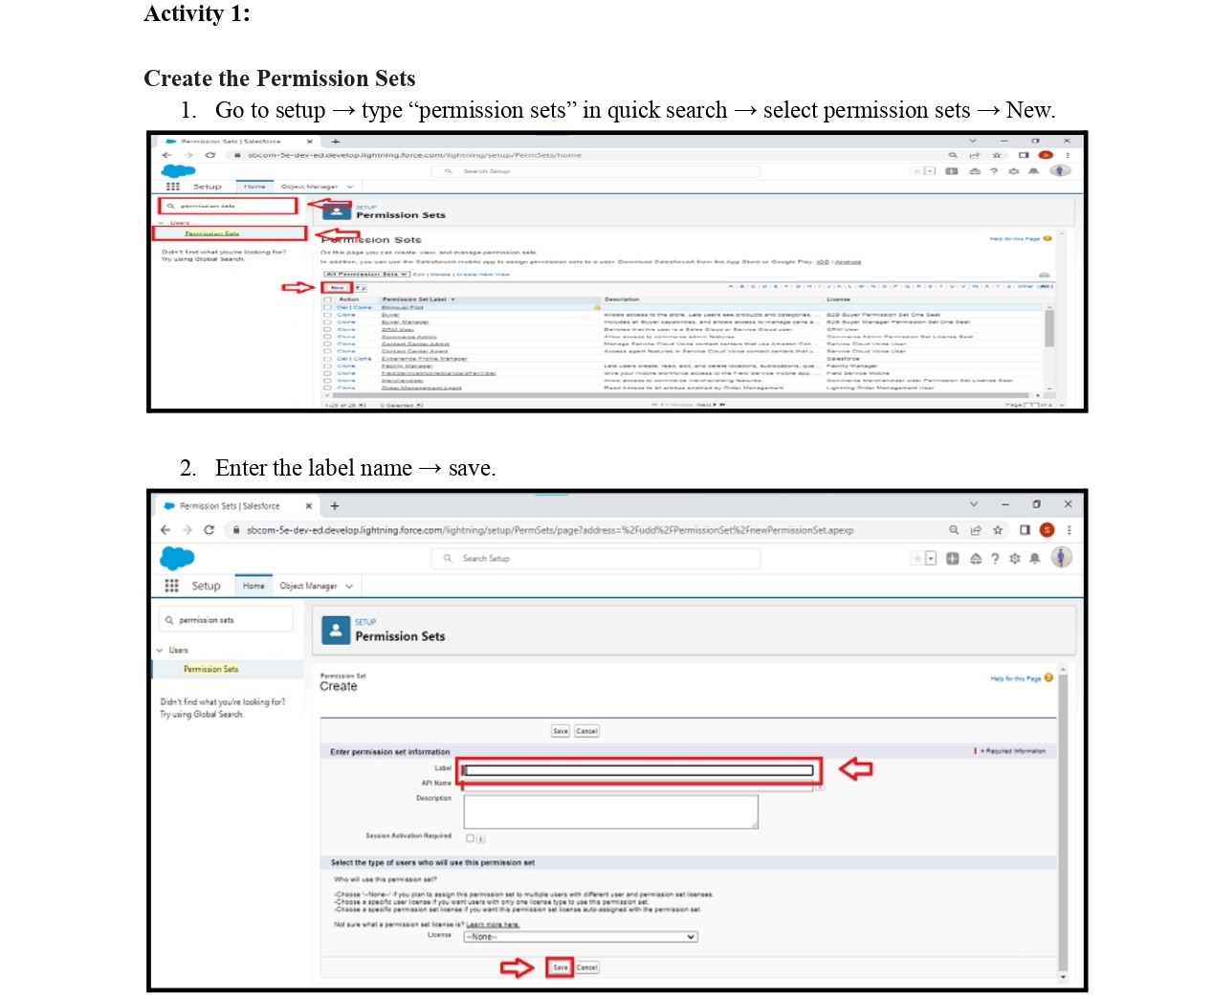

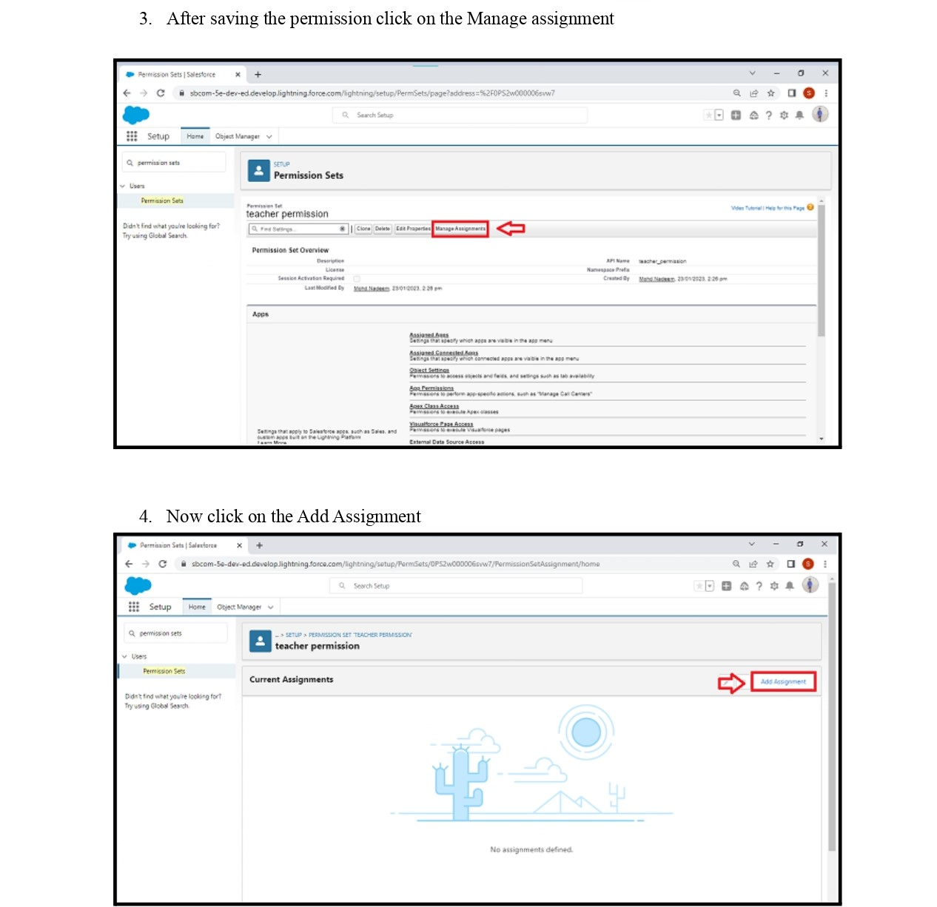

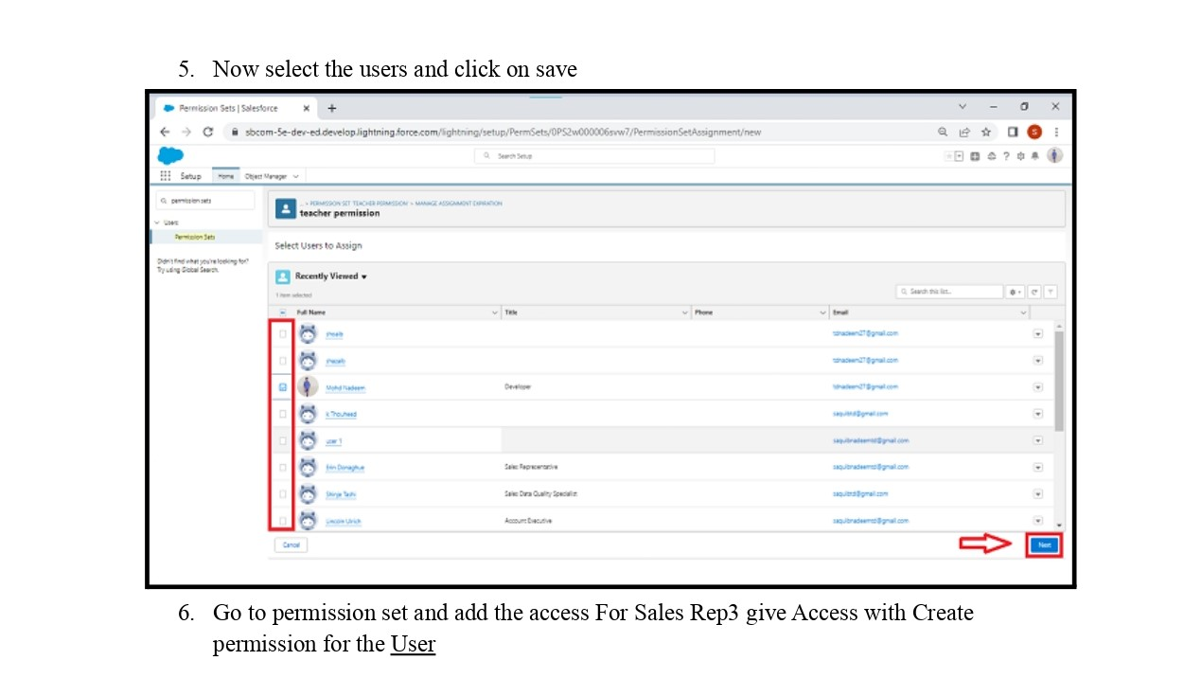

Mailstone 9:setup for OWD

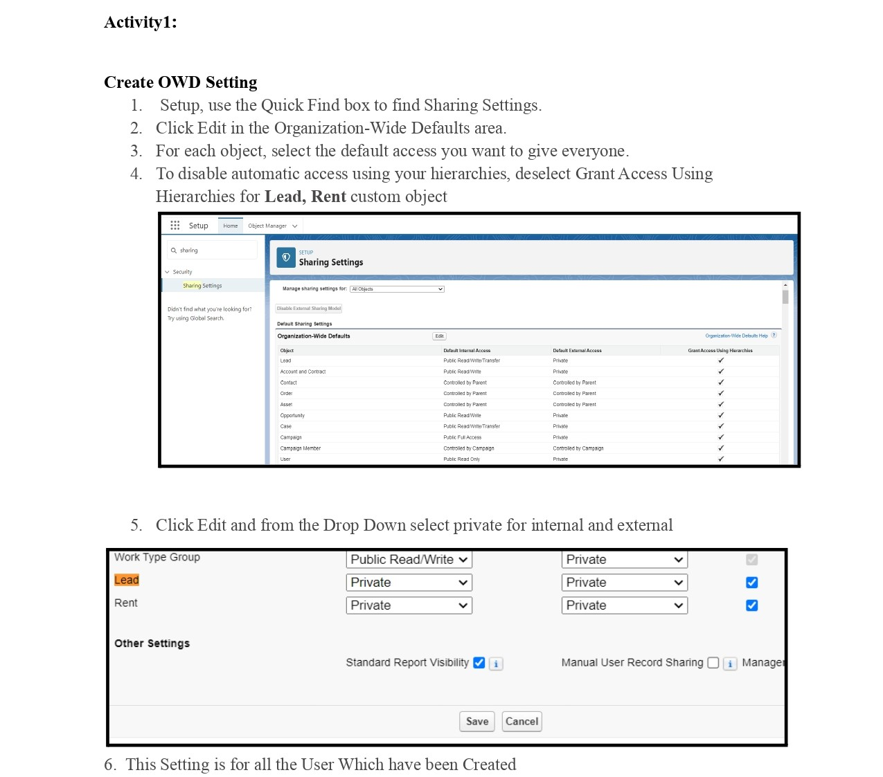

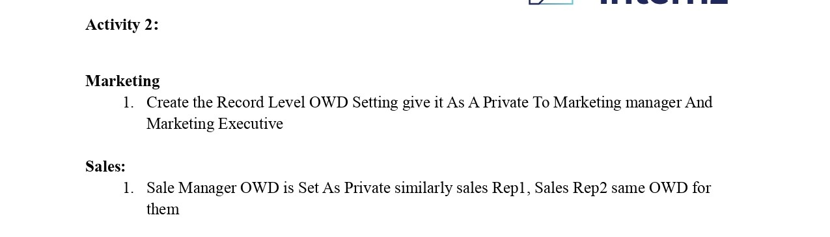

Mailstone 10:Report

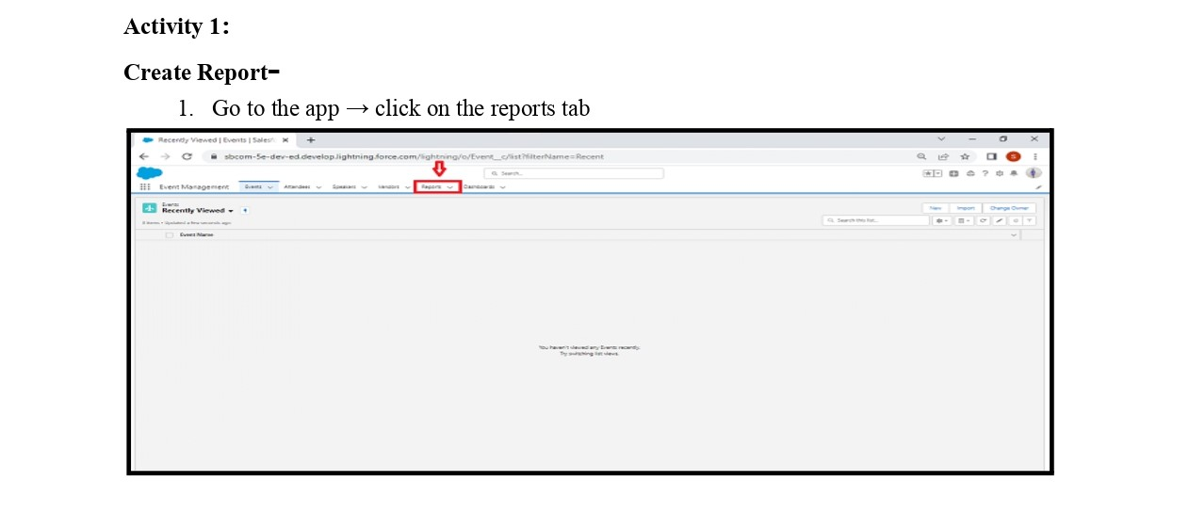

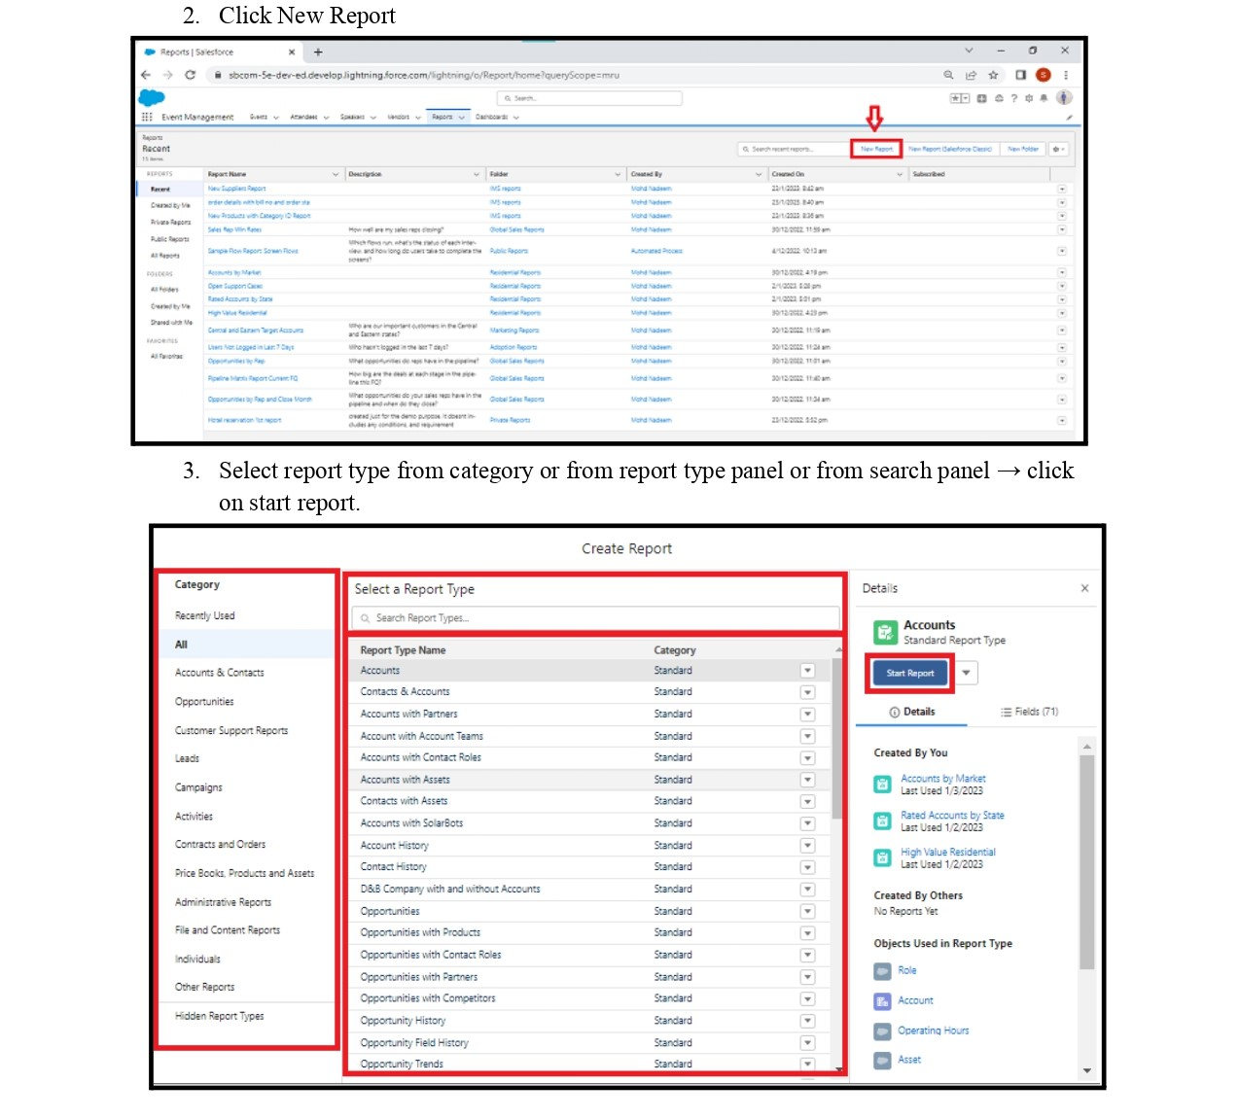

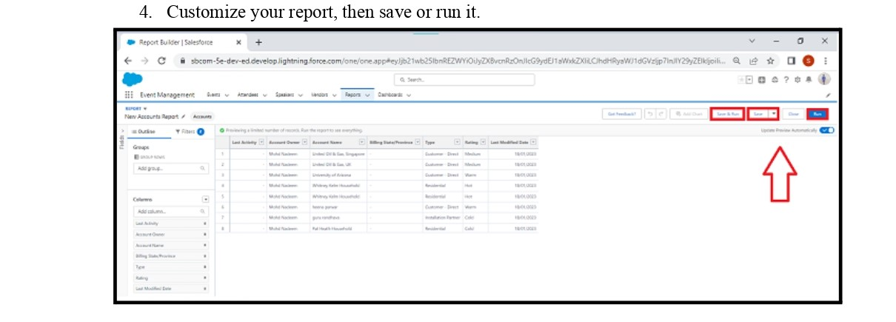

Mailstone 11:Dashboards

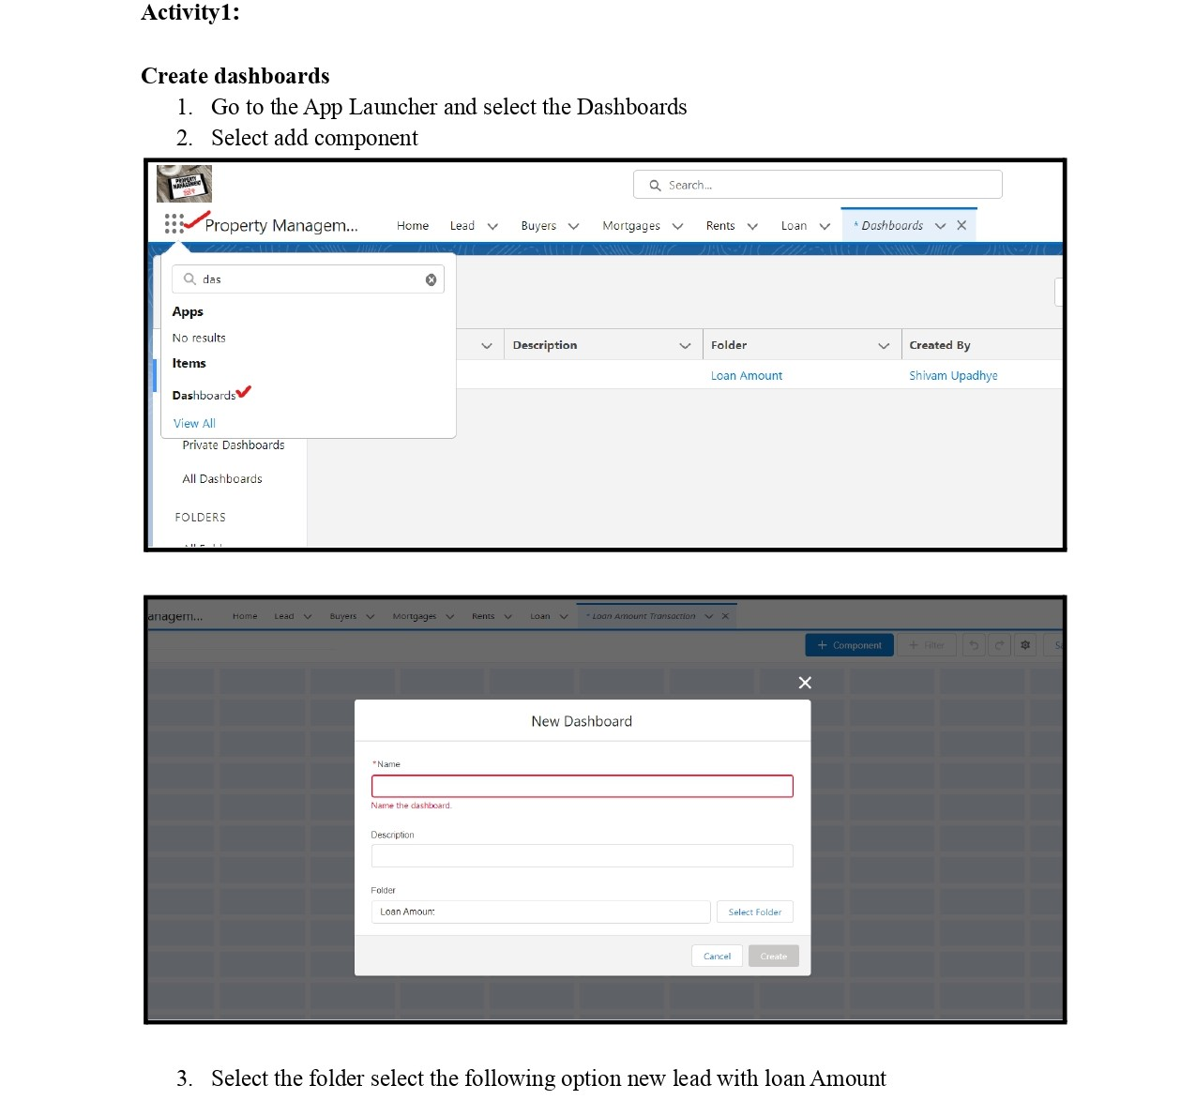

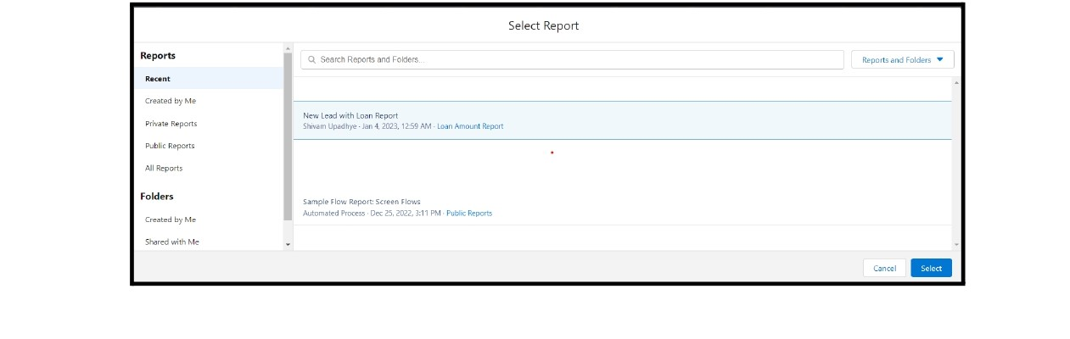

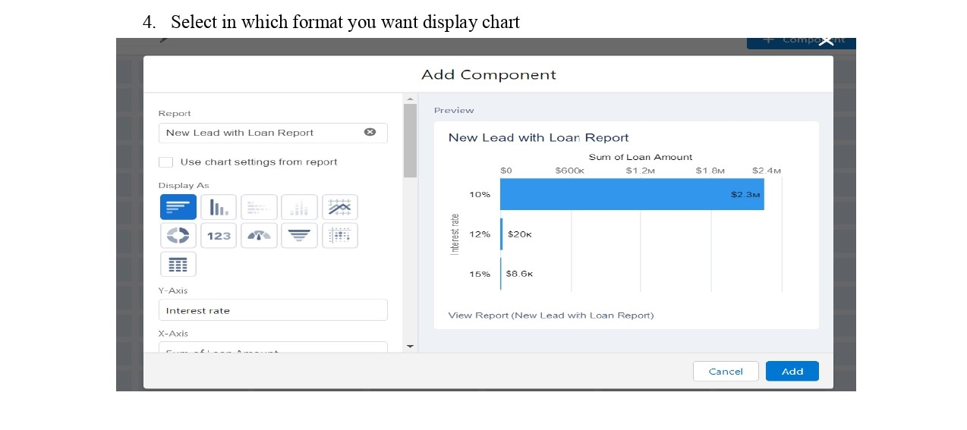

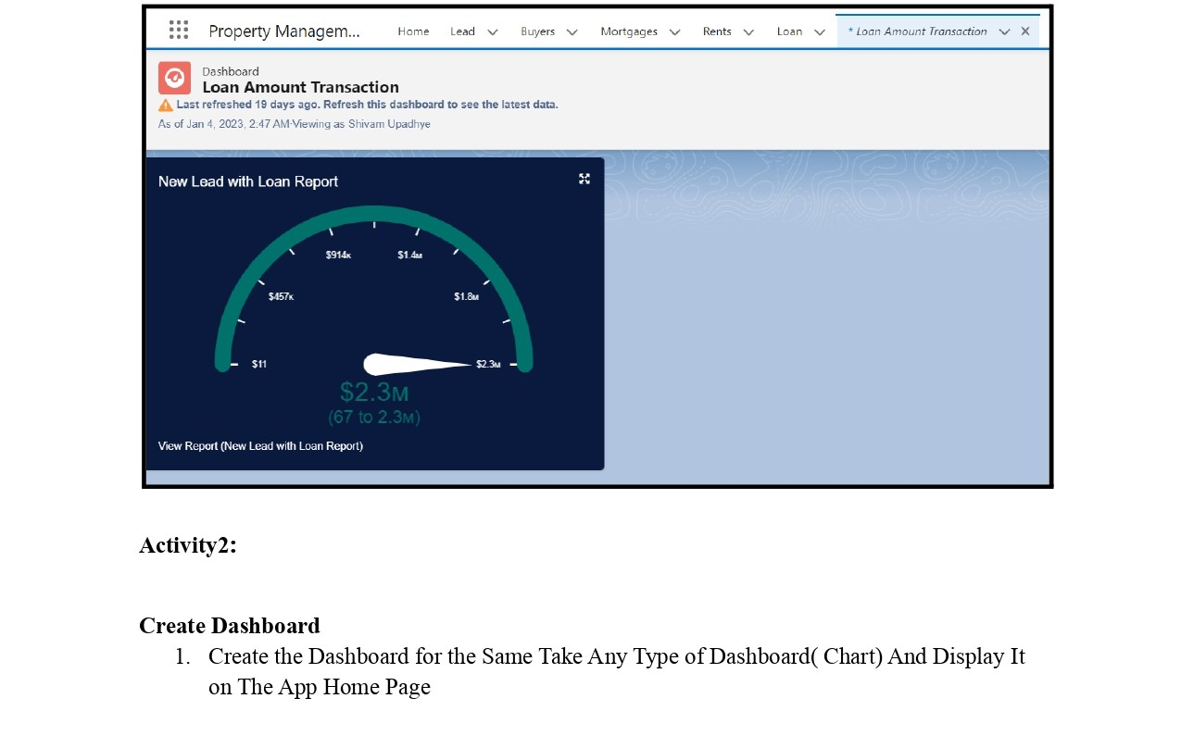

**TRAILHEAD PROFILE PUBLIC URL**

Team leader :<https://trailblazer.me/id/vivekeaswaran17>

Team member 1:<https://trailblazer.me/id/rchandran53>

Team member 2:<https://trailblazer.me/id/hhariharan3>

Team member 3:<https://trailblazer.me/id/pbalamurugan10>

**Advantages and disadvantages**

**Advantages:**

1. Customization: Salesforce is highly customizable, allowing property management companies to tailor the application to their specific needs. Companies can easily add or remove features, fields, and functionality as their needs change.
2. Integration: Salesforce integrates with many other platforms, such as accounting software and marketing automation tools. This integration can help streamline processes and improve overall efficiency.
3. Mobile Access: Salesforce offers mobile access, allowing property managers to access information and complete tasks on the go. This feature can help managers stay productive while out in the field.
4. Automated Workflows: Salesforce allows for the creation of automated workflows that can streamline processes and reduce errors. For example, notifications can be sent when a lease is up for renewal, or work orders can be automatically generated when a maintenance request is submitted.
5. Data Analysis: Salesforce provides robust reporting and analytics capabilities that can help property managers make informed decisions based on real-time data. Managers can track leasing metrics, revenue, expenses, and other important KPIs to make data-driven decisions.
6. Collaboration: Salesforce enables collaboration among teams, allowing property managers to work together on projects and share information easily. This feature can improve communication and enhance productive.

**Disadvantages:**

1. Cost: Salesforce can be expensive, particularly for small property management companies. The cost of licensing, customization, and training can add up quickly, making it difficult for some companies to justify the investment.
2. Complexity: Salesforce is a complex platform that can take time to learn and master. Property management companies may need to invest in training or hire consultants to help them get the most out of the system.
3. Customization: While customization is a strength of Salesforce, it can also be a potential disadvantage. Companies may become overly reliant on customized features, making it difficult to switch to a different platform in the future.
4. Integration: While Salesforce does integrate with many other platforms, some integrations may require additional development or customization, which can add to the cost and complexity.
5. Limited Support: Salesforce support is typically limited to technical issues with the platform, rather than specific property management challenges. This can make it difficult for property management companies to get the support they need when facing complex challenges.

**APPLICATIONS**

salesforce can be applied in many areas of property management.

examples:

1. Leasing and Tenant Management: Salesforce can be used to manage leasing and tenant data, including lease terms, rent payments, and maintenance requests. It can also be used to automate lease renewal processes and track tenant satisfaction.
2. Maintenance Management: Salesforce can be used to manage maintenance requests, work orders, and preventative maintenance schedules. It can also track vendor performance and costs associated with maintenance activities.
3. Accounting and Financial Management: Salesforce can be used to manage financial data, including rent collections, expenses, and revenue. It can also be used to automate accounting processes and generate financial reports.
4. Marketing and Sales: Salesforce can be used to manage leads and prospects, track marketing campaigns, and automate follow-up processes. It can also be used to manage sales pipelines and track the performance of sales teams.
5. Property and Asset Management: Salesforce can be used to manage property and asset data, including property details, asset tracking, and insurance information. It can also be used to automate property inspections and track compliance with regulatory requirements.

**CONCLUSION**

property management applications using Salesforce offer several advantages, including customization, integration, mobile access, automated workflows, data analysis, and collaboration. However, there are also potential disadvantages to consider, such as cost, complexity, customization limitations, integration challenges, and limited support.

Property management applications using Salesforce can be applied in many areas, including leasing and tenant management, maintenance management, accounting and financial management, marketing and sales, and property and asset management. By leveraging the capabilities of Salesforce, property management companies can improve operational efficiency, increase productivity, and make data-driven decisions based on real-time data

n summary, Salesforce can be an effective solution for property management applications, providing numerous advantages such as customization, integration, mobile access, automated workflows, data analysis, and collaboration. However, there are also potential disadvantages to consider such as cost, complexity, customization, integration, and limited support.

Salesforce can be applied to various areas of property management including leasing and tenant management, maintenance management, accounting and financial management, marketing and sales, and property and asset management. It provides a unified platform for managing data and .

**FUTURE SCOPE**

1. Artificial Intelligence and Machine Learning: Salesforce is already incorporating AI and machine learning capabilities into their platform. These technologies could be used to automate tasks, predict maintenance needs, and improve decision-making in property management.
2. Internet of Things (IoT) Integration: Integrating IoT devices with Salesforce could allow for real-time monitoring and data collection of property assets, such as heating and cooling systems, lighting, and security systems.
3. Augmented Reality: Augmented reality could be used to visualize property designs and layouts, allowing property managers to make more informed decisions and improve communication with tenants.
4. Blockchain: The use of blockchain could improve security, transparency, and efficiency in property management. It could be used for things like rent payments, property ownership, and maintenance records.
5. Virtual Assistants: Virtual assistants could be used to automate repetitive tasks and provide 24/7 support to tenants and property managers.
6. Mobile Apps: While Salesforce already offers mobile access, a dedicated mobile app for property management could provide additional features and functionality for managers on the go.

**DEMO LINK:** <https://youtube.com/watch?v=SjwFwr35v5U&feature=share>